The hands & feet of calvary
United Church Of Christ
March 2024
1231 Route 100, Barto PA 19504
phone # 610-652-5023
Church Office: calvaryucc@gmail.com Website: www.calvaryuccbarto.com
Clothing & Outreach Ministry: calvarysclosetbarto@gmail.com
Join us on Facebook! Calvary UCC Barto

Dave Brumbaugh, Pastor
Heather Spaccarelli, Administrator
Becky Crist, Consistory President
Linda Himeback, Treasurer

Pastor’s Message

Lent culminates this year on Saturday, March 30. The season for penitence, contemplation, and applying disciplines of the faith leads us past the events of holy week – Palm Sunday, the Last Supper, Jesus’ arrest, trial, and crucifixion - to the resurrection. We cannot forget, nor escape, those realities. In truth, we need to embrace them for what they are – gateways to our spiritual freedom that take us to the day of resurrection and beyond. Easter brings us new life and possibilities here, now, and for our future days as the church and as Christ’s disciples. Yes, heaven awaits us, and that glory will be even better than the bible describes it, I believe. But what makes Easter even more powerful and meaningful is that we have taken a journey with Christ that began in a cradle in Bethlehem and traveled to the open tomb. We have experienced the ministry of Jesus
through the eyes of Apostles, common folks, Jewish leaders, and the authors who wrote those faith stories in the gospels. The Epistles – the larger portion of the New Testament – describe the beginnings of the church. Calvary UCC has its unique journey throughout the decades, and over a century, as a living witness to the power and influence of the
resurrection. I invite our members and friends to join us for the continuing portion of
Lent during March, and the celebration of the resurrection each Sunday.
We will experience wonderful music by professional musicians in word, song,
and instruments. We will continue the focus theme of “Jesus is for________” until Holy Week. Remember that Sundays during Lent are not part of the tradition of Lent, but continuing celebrations of the resurrection and the history and traditions of our faith. Please see the worship schedule and highlights in this newsletter and on-line for each of the services during March. One Great Hour of Sharing offerings will be dedicated on March 10. However, we can give to this important relief offering for folks who have extreme needs anytime during the year. Holy Communion will be celebrated on Maundy Thursday and Easter. I extend a blessed and happy Easter to all of our members, friends, and to a world in need of renewal, refreshment, and eternal hope.
Blessings,

Pastor Dave

___________________________________

3/10 Consistory Meeting, Following Worship

2024 Calvary Consistory Officers

President – Becky Crist
Vice President – Rona Britton
Secretary – Sherry Bauer
Treasurer – Linda Himeback

Elders: Sherry Bauer, Marlene Latshaw, Tracey Frey
Deacons: Rona Britton, Becky Crist, Sonya Spotts, Linda West, Connie Jordan

**Attention! There are vacancies on the 2024 Consistory, and we would like YOU to join us! Please contact Becky Crist or Pastor Dave if you have interest in joining us, OR if you
have any questions!**

Calvary’s Corner, a note from your Consistory…
As we begin March, we are waiting to see if the groundhog is correct in predicting
Spring around the corner, or if we will have a cold, snowy month end. It wouldn’t be the first time we had a snowy Easter, especially since Easter is in March this year. The good news is that Spring training has begun for all who love Baseball! Warmer days are sure to come. We may not see the tulips and daffodils outside, but we will have them inside for Easter. Please see the order form to sponsor plants and make our sanctuary colorful and joyful for Easter Sunday! All plants will be available for you to take along after the Easter Service. Orders can be mailed to the church, dropped in the offering plate, or handed to Joan Albitz. As we travel our journey through Lent, please look for some Easter announcements to come. Christian Education will be meeting to discuss The Easter Egg Decorating Display and possible Egg hunt. Stay tuned!

Do you enjoy the special music Sundays at Calvary? Then mark your calendars and invite your friends and neighbors to join us in March. Pastor Dave has lined up special music for every Sunday in March. We kick off March 3 with Threefold Blessing, then enjoy the vocal talents of Debi Wahl, next Craig Kenney will fill our service with joy through his trumpet, and for Palm Sunday and Easter Ron Stabinsky will share his amazing piano skills with us. Calvary will be uplifted and filled with music! What a blessing! Don’t miss it!

Planning has begun for our Back-to-School Giveaway. Collection boxes are going out. We are looking for new backpacks, pencils, notebooks, crayons, etc. If you have any questions, please contact the church office. Each of you are a blessing! The members of Calvary continue to step up, supporting us financially, helping to prepare meals, flea market sales, giveaways,
sorting and organizing donations, and much, much more. We cannot thank you enough for all you have done and continue to do to strengthen the work and ministry at Calvary. May we always be reminded of how good our Lord is. Our world is still experiencing troubling times, however there is always a story of hope and blessings to be found. God is Good!
May you feel the Lord’s blessings, and be renewed and rejoice every day,

Your Consistory,

Becky, Rona, Sherry, Marlene, Sonya, Linda, Connie, Tracey and Pastor Dave

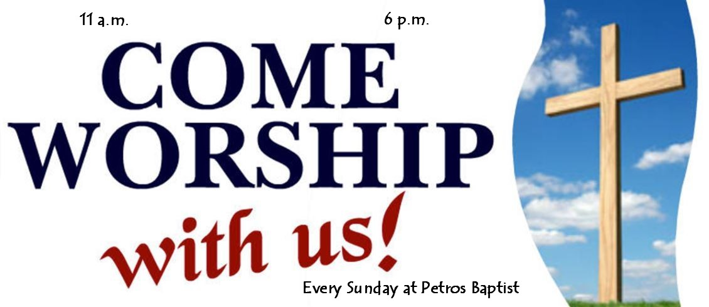

Pastor Dave Brumbaugh - Worship begins at 9:30am... unless otherwise noted!

Join us in person or via Facebook Live or Zoom!

No computer or smart phone? No problem! You only need a phone to listen to Worship via Zoom!
Dial: 1-646-558-8656 and when prompted, enter the Meeting ID 913 8085 8414 and listen to the voice prompts for simple directions. If you are asked for a password/passcode, enter 848423

March Worship Schedule
March 3 – Third Sunday in Lent
Special Music: Threefold Blessing
1 Corinthians 1:18-25
John 2:13-22
Message “Jesus – for Holiness”
March 10 – Fourth Sunday in Lent
Special Music: Debi Wahl, vocalist
One Great Hour of Sharing Dedication
Ephesians 2:1-10
John 3:14-21
Message “Jesus – for Truth Seekers”
March 17 – Fifth Sunday in Lent
Special Music: Craig Kenney, Trumpet
Hebrews 5:5-10
John 12:20-33
Message “Jesus – for God”

HOLY WEEK
March 24 – Palm Sunday (Celebration of the Palms)
Special Music: Ron Stabinsky, Piano
Philippians 2:5-11
Mark 11:1-11
Message “Who Is Jesus?”
March 28 – Maundy Thursday -Worship at 7:00pm
Holy Communion
Theme “Passover Events”
March 29 – Good Friday -Worship at 7:00pm
Theme “Dare to Journey the Cross”
March 31 – Easter Celebration of the Resurrection
Special Music: Ron Stabinsky, Piano
Holy Communion
1 Corinthians 15:1-11
John 20:1-20
Message “No One Can Take RESURRECTION Away From Us!!!!”

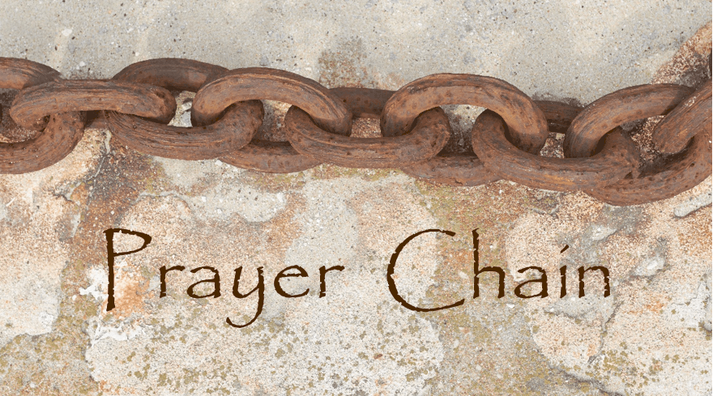

The Prayer Chain is ready to pray for you!
If you need prayers for yourself or a loved one, reach out to Pastor Dave, or the church office and we will send the request through the Prayer Chain.

A Special Announcement for Special Music!
We all enjoy hearing live music which fills our church and hearts with joy.
Some notable dates include the Third Sunday in Lent, March 3, we will enjoy hearing the music of Threefold Blessing. The Fourth Sunday in Lent, Debi Wahl will provide her gift of song.
Palm Sunday March 24 and Easter March 31, Ron Stabinsky will be playing the piano.
Please make note of these dates on your calendar and bring a friend to Worship!

The Property Committee will meet on Tuesday March 5, at 4pm in Fellowship Hall. Topics to be discussed include the sound system project and the electronic sign. Anyone interested in these, or other church property related items is welcome to attend!

Volunteers are needed to unpack clothing in Fellowship Hall on Tuesday March 12th, from 12:30-5:00pm.

Lunch Bunch! Join us for a lunchtime gathering, at a local restaurant, for conversation, food, and fellowship! Everyone is welcome to attend, just sign up (fellowship board on the ramp) so that the selected restaurant has enough space set aside for our group. Tuesday March 12th, we will meet at Tosco’s in Pennsburg at 11:30am. If you have any questions, please contact Kim Yerger (1-610-730-7204)

25₵ Sale & Indoor Flea Market will take place on Saturday March 17th from 8am- 11am. If you are able to lend a hand with either set up or tear down, or anytime in between please reach out to Rona to help downstairs, or Kim Marburger to help upstairs with the 25₵ sale.
Thank you for your time and talents to help make these events successful!

Fellowship & Social Ministries will meet on Thursday March 21st at 7pm in Fellowship Hall. We will be discussing our Free Community Back-to-School Outreach Event that is scheduled for Saturday July 27th. If you are interested in helping this annual event to be another huge success, please plan to attend this meeting. Interested in helping? We are looking for volunteers to help at the various stations during the event! To volunteer or if you have any suggestions, ideas or questions, please see Becky Crist.

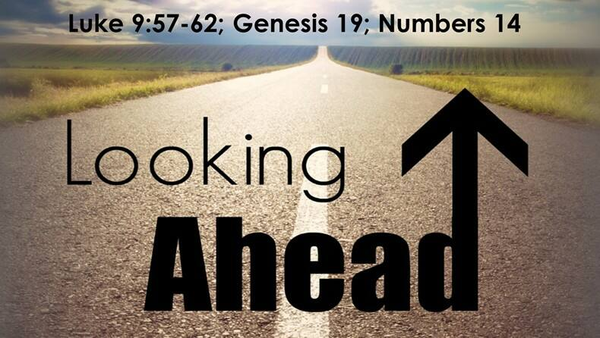

25₵ Sale & Indoor & Outdoor Flea Market will take place on Saturday April 20th from 8am- 11am. Outdoor space will be available for vendors!

A Clothing and More Giveaway is scheduled for Saturday April 27 between 9am-11am in Fellowship Hall.

* Thank You to everyone that helps promote, volunteer, participates, and
gives their time to make events successful! *

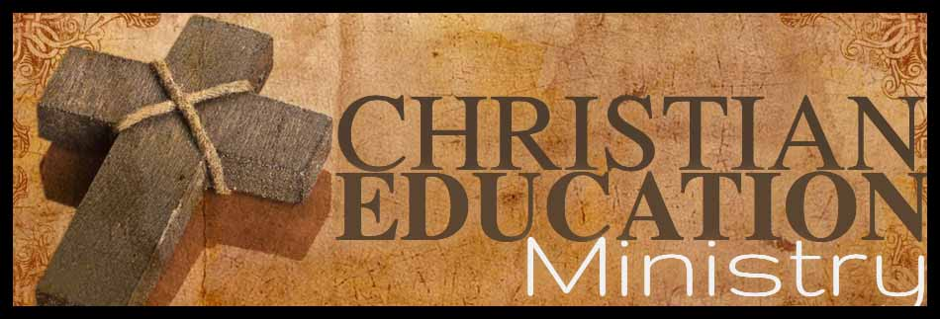

~ Time to break out those craft supplies and get creative! Decorate an Easter Egg for our church-wide decorating contest, and bring them to church on Palm Sunday, 3/24/24. The eggs will be displayed for everyone to see in the Narthex. Prizes will be awarded on Easter Sunday.

~ All attendees at Worship on Easter Sunday will receive an Easter Basket from
the Christian Education Ministry.

~ Upcoming Event! We will gather for Bingo and Lunch on April 28th, following Worship. Please bring a wrapped gift $5. Lunch will be provided. Bring a dessert to share if you wish.

*For any questions regarding any of these Christian Education events, please see
Becky Crist, Tracey Frey or Connie Jordan.

Basket Raffle Update: This year we will hold one basket raffle fundraiser. We are preparing to make this the biggest and most exciting basket raffle at Calvary yet! To help make this successful, please have all raffle baskets to Calvary by Sunday August 18.
Tickets will be sold between Saturday August 24 all the way up through our Annual Christmas Bazaar, on Saturday November 16. Winning tickets will be drawn at 1:00pm at the end of the Bazaar. (Winners do not need to be present to win!)
Any additional questions may be directed to Kim Marburger or the church office.

Please remember to swipe your Save-A-Tape card when you check out at Redner’s Markets.
The Save-A-Tape card MUST be used for your purchase to be credit to the church’s rebate total. Thanks again to everyone for turning in the tapes. Thank you to Marlene Latshaw for all the organizing and adding!
(If you aren’t familiar with the Save-A-Tape program, stop by the customer service desk next time you shop at Redner’s)

YOU are invited to gather for “Coffee and Conversation” on Sunday mornings at 8:45 AM in Calvary’s Fellowship Hall. Everyone is welcome to attend this time of fellowship! If you wish to provide a breakfast danish, treat, fruit, or snack, please see Marlene or Becky.

Niantic - Union Cemetery Guidelines
All planting of shrubs, trees or plants is prohibited. Remove all winter decorations 3 weeks before Easter. April through October all flowers and memorials will be removed 7 days after all holidays. All arrangements affixed on top of the gravestones may remain until they are unsightly.

Aluminum Can Collection/Recycling at Calvary Please continue to bring your bagged aluminum cans to the lower double doors and place them in the black can marked “can recycling”

Church News Box at Calvary
The little mailbox on a red pedestal holds copies of monthly newsletters, calendars of events, daily devotional books, and more! If you pick up your newsletter in person, you are invited to pick up your newsletters from this box if you are not able to pick it up while attending Worship.
This mailbox is open anyone! The red pedestal mailbox is located at Calvary’s lower double doors.

Online Giving at Calvary!
Online Giving at Calvary! With this giving option through Vanco, you have the ability to choose where you would like your offering designated, whether it be the General Budget, OCWM, Building Maintenance, or the Memorial Fund. There are 3 ways that you can access Vanco to use online, electronic giving...
- Use the following link on your computer:
https://secure.myvanco.com/L-ZJAT/home
- Use the camera on your smartphone or tablet to scan the below QR code, which will provide a link to the page for online giving.
3. Download the Vanco Mobile Faith Engagement App from your app store on your smartphone or tablet and create an account.

*If you have any questions regarding using the Vanco online giving option, please contact Heather.

USAgain CLOTHING BINS at Calvary Thank you to all that help to fill our bins and help to reduce, reuse, and recycle clothing materials! Please keep in mind that once bags are dropped into the collection bins, the church has no access to them. So, if you are wanting to donate items to the Flea Market, or to Calvary’s Closet, please drop your items off at the lower doors. Thank you!

USAgain is a clothing and shoes collection company. 90% of the gently used clothes and shoes collected are reused. The items are taken to a warehouse where they are bundled into half ton cubes and shipped to Central America. For every full bin, one tree is planted. Calvary UCC has five bins on our property and we receive $425/month from USAgain for being a collection site.

Calvary’s Fellowship & Social Ministries Wish List
As you are probably aware by now, the Fellowship & Social Ministries Committee are doing
BIG things around Calvary! You may have noticed over the last few months different requests for items that make the flea markets possible. The items that we use the most have been compiled into a list to make it simple to find what is needed, if you would like to donate any of them.

- Kitchen size, 13-gallon garbage bags
- 3M Blue painters’ tape (1” width)
- Avery self-adhesive address labels #5160
- Ziplock bags; 1 to 3 gallon sizes & sandwich size.
- Paper grocery or shopping bags

Any of these items may be given to Heather, Linda West, Rona, or Kim Marburger at
any time. Thank you for your continued support of our efforts!

___Notes from the Administrator’s desk…_____

- *The APRIL Newsletter Deadline is
Noon on Tuesday March 19th*

March Birthdays

3/2 Jesse Britton & Sharon Stofflet
3/7 William Angstadt
3/9 Sallie Fronheiser
3/11 Brooke Moatz
3/17 Stephanie Frantz
3/22 Carl Kirschner
3/24 Isaac Longacre, Carolyn Nentwick & Kallie Spotts
3/27 Ashley Lynn Haring
3/28 Genevieve Felegie
3/30 Randy Kahler

*If you have a Birthday during the month and it was not mentioned, or the date is listed wrong, please let the office know. We are working to keep our records updated and your help in this effort is appreciated. Thank you!

- If you are going to the hospital, having surgery, or have recently been in the hospital, please inform Pastor Dave in one of three ways:
- Call him on his cell phone: 1-717-466-1216
- Email him: trumpet@dejazzd.com
- Call the Church office (1-610-652-5023) and leave a message

Katherine & George Jacob, Jr.
14 Standish Ln.
Hereford, PA 18056
1-610-702-4221

Barbara Moser
Frederick Living
2849 Big Rd. Apt 1102
Zieglerville, PA 19492
1-610-652-2263

Paul Schollenberger
Frederick Living
2849 Big Rd. Apt 1225
Zieglerville, PA 19492
1-610-652-5503

Linda Hilbert
Wilson Manor - Saucony Cross Complex
240 Wilson Manor
Kutztown, PA 19530-8614
1-484-641-5248

Thelma Borchelt
Frederick Living
2849 Big Rd. Apt. 1211
Zieglerville, PA 19492
1-610-652-5115

Sallie & Grant Fronheiser
241 Hill Church Rd.
Bechtelsville, PA 19505
1-484-944-4504

Janet Kulp
Amity Place Room #123
139 Old Swede Rd.
Douglassville, PA 19518
1-610-385-9745

Lillian Miller
3711 Hershey Ct.
Whitehall, PA 18052-3369
1-610-769-7318

Eileen Haring
1828 Big Rd.
Gilbertsville, PA 19525
1-610-754-6046

George LaFaver
450 N. Krocks Rd. Apt 367
Allentown, PA 18106
1-484-765-9191

An order form for Easter Flowers has been included in this newsletter. Kindly return your completed form with payment to Joan Albitz, drop it in the offering plate, or mail it to the church office by Sunday March 17.

Please plan to take your plants with
you following the Easter Sunday
Worship service on March 31.

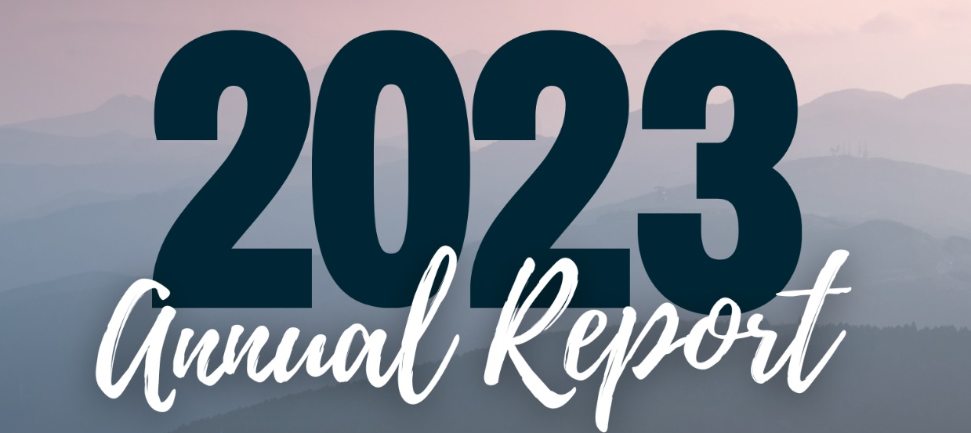

Pastor’s Annual Report, December 2023

I am grateful to God and our Lord and Savior Jesus Christ for the continuing privilege of being your pastor at Calvary UCC. We are a caring congregation with mission reaching into the nearby community and beyond. It is a challenge being the church today. Faith doesn’t seem to be much of an over-all priority for people in our culture or country. Numbers of worship attenders reveal this reality. Yet, God is a living God. Christ is present. We know this at our faith core. The members, consistory, many committees, commissions, councils, support groups and working groups at Calvary are blessings to God’s kingdom, and that is only possible with the Holy Spirit’s guidance, strength, and encouragement. I am thankful for the grace that the Lord gives to us every day.
My responsibilities as pastor of Calvary UCC cover a variety of obligations as pastor to the members of Calvary, to the PSEC Conference, to the Covenant Association, and to the community at large. As pastor to Calvary’s members my responsibilities need to be especially focused upon a post Covid-19 approach of helping our Church to re-engage in activities (traditional and new), worship leadership, performing the Rites and Sacraments, teaching (from the pulpit, in meetings, bible study, etc.), visitation of the hospitalized and shut-ins,
administration, office time, and adding a guiding and supportive presence to our leaders and members in their various roles in the life of the Church. Heather is a key team member in helping me to be the pastor that Calvary needs. She and I meet every week and communicate almost every day both in office and out-of-office with texts, emails, and phone calls. Becky as our consistory president, is also a key contributor to my ministry, as we “bounce” ideas off of one another frequently, and talk about how to move Calvary forward into a healthier future in order to maintain and to grow our Church. Many other leaders, both appointed, and who have assumed leadership roles, continue to bless our church. As your pastor, I also see myself as a pastor to the wider church, and to our community. This is similar to how many, if not most, members at Calvary “put into practice” ministry and mission – working together as a statement of our faithfulness to one another as members of the body of Christ, yet accountable to be “like Christ” to others in our surrounding communities, where possible.
As well as having primary responsibilities as your designated pastor, working approximately 30-34 hours per week, a portion of that time is mandated to every UCC pastor as members of our denomination. My responsibilities as a UCC pastor to the PSEC Conference and Covenant Association are similar. In order for an active pastor to maintain “standing” in our Conference and Association, there are requirements that are expected to be fulfilled annually, and for a three-year cycle of ministry. Among those expectations and requirements are: 1). To take boundary and advanced boundary training. 2). To attend Covenant Association and PSEC meetings. 3). To occasionally meet with the Covenant Association for review. 4). To participate in diversity training. 5). To engage with UCC colleagues in ministerium activities. 6). To complete annual statistical review forms of Calvary’s membership, Leadership, and other data. I have completed most of these requirements
over the past two years. In total, these requirements take about 55 hours a year to complete. That is almost 2 weeks each year.
My responsibilities to the community are mostly self-determined and directed, but with Calvary’s sense of mission and ministry to others outside of our Church (geographically and otherwise), that has become an important part of helping our Church to be recognized and appreciated - beyond our Rt. 100 location. At the same time, it is important to find as many ways possible to work together to attract new folks to consider a larger participation in

helping us to be that “community church” and to consider joining us with a greater commitment of discipleship.
The role of pastor/activities of the pastor has changed over the past 20-30 years. Declining Church membership and attendance throughout our country leads us to continually evaluate and access how we do ministry and mission. Evangelism has become increasingly important, although I would argue that it has always been at the forefront of biblical testimony and efforts, though long forgotten by our major denominations, in my opinion. Pastors who have failed to embrace this reality have either left ministry or are relegated to being a “caretaker” for dying churches. I am not that kind of pastor, and my efforts in ministry throughout 37 years of ordained ministry have mostly produced growth. It is important that the leaders and members of Calvary UCC understand these realities and my focus of helping Calvary to position itself for a brighter future than many churches face. I will continue to advocate for, and to encourage an understanding of these realities, and to advocate for Calvary’s growth. Church growth these days is not automatic. Growth takes smart work and hard work. It takes a pastor’s willingness to advocate for changes that may not be popular or immediately embraced. It also takes a congregation to understand that the past does not determine the future. The present and future decisions we make have the most important effect on a church’s possibility for growth. Remember these two words: EFFECTIVE AND RELEVANT. These have been my two most “non-theological” and “non-biblical” words to drive my ministry these many decades.
How can Calvary’s congregation help me to be the best pastor that I can be? Love me as Christ loves you and me, and as I love you. Pray for me and my ministry among you and among others in the community and beyond. Tell me the truth…not what you think I want to hear. Understand that I am your designated pastor contracted for ¾ time and not full time. There are weeks that I work past 30-34 hours per week, but I try to balance those weeks out and take additional time off in future weeks. It is helpful to understand how I administrate my time to maximize ministry and mission efforts. I am very good at time management. What I get done in ¾ time takes many pastors a full time commitment to complete. I know this by talking with my colleagues.
Calvary has some really special people, and I notice more than you think I do. I watch, listen, observe, and am grateful for the “air” of truly welcoming members and Christian people. There is a genuine depth to many people’s faith at our Church. This is a compliment that I do not make lightly, because it is shared by many other people with me on your/our behalf. Every one of our guest musicians and mission partners who come to our church are glad to be here, voice their appreciation to me about our welcoming and friendliness, and look forward to coming back. That says a lot!!!

In Christ, Rev. David R. Brumbaugh

Thoughts from our 2023 Consistory President
Greetings members of Calvary. It has been my pleasure to be the Consistory President in 2023. In 2023 consistory worked out a contract to continue Pastor Dave for an 18-month term which would take him to the end of 2024. We are blessed at Calvary to have someone who has connections to allow us to bring in special music during Lent, Advent and Christmas.
Once again, I am in awe of Calvary and its members and volunteers. All together we worked very hard to run our monthly 25₵ sales/Pop up sales and give aways. The countless hours spent by those who volunteer just amazes me every month and I would like to acknowledge and say ‘thank you’ to those who put so much time and effort into helping Calvary achieve our goals - not only financially, but by also being able to be a community partner to The Ann Frances Outreach Foundation, and those who need assistance from Calvary’s Closet.
I must repeat what I said last year: Calvary is much more than the building; it is the people. We miss those who are unable to attend on a weekly basis. We miss those that have left the church for other reasons. We also miss those that are struggling with their place in the church and haven’t been able to come back for whatever reason. Know that you are loved, and we welcome you with open arms.
The Consistory held about 9 meetings this year, we worked on the 2024 budget and approved many projects that needed to be done at Calvary. I want to take a minute to Thank Kim Marburger and Harold Albitz for their service on consistory over the past 6 years. Their contributions do not go unnoticed. We are always looking for members who would like to serve on Consistory. If you have ever questioned why something was done, or where the money goes, or anything in general about what Consistory does you are always welcome to join us at any time for one of our meetings.
Looking forward to a bright and wonderful 2024. Blessings to all of you and your families.
Respectfully submitted,
Becky Crist

Worship Commission - 2023 Annual Report

Members of the Worship Commission are Joan Albitz, Sherry Bauer, Harold Albitz, Kim
Marburger, Tracey Frey and Marlene Latshaw.
- Formulated the 2023 church calendar.
- Prepared for Holy Communion which was shared 10 times throughout the year.
- Music for the worship services was downloaded and played on an iPad when we did not have a musical guest, by Kim Marburger.
- Guest musicians and vocalist included Threefold Blessing, Ron Stabinsky, Craig Kenney, Debi Wahl, Ernie Yeagley, Ron Stabinsky, and The Pedersons.
- Plants were displayed in the sanctuary on Easter Sunday, and Christmas Eve. All were purchased by members and friends of Calvary.
- Carnations were handed out on Mother’s Day, and Candy bars on Father’s Day.
- The church was decorated for Harvest Home and the collected food items were displayed.
- Seasonal décor beautified our Sanctuary throughout the year.
- The annual Thanksgiving Eve Service was held at Christ Niantic Church with Pastor Dave participating.
- 4th Sunday in Advent was held at 9:30 am on Christmas Eve.
- Candlelight Holy Communion Service was held at 4:00 p.m. on Christmas Eve.
Consistory and lay people along with supply pastors filled in throughout the year during the pastor’s absence.
Thanks to everyone who participated in these activities. Please talk to any member of the commission if you would like to help plan the church year.
May God Bless You All!!!

Fellowship & Social Ministries 2023
As we close out 2023, we continued with our 25₵ sales, along with flea markets. We hosted a couple of free community lunches, along with clothing & household item giveaways. Two Basket raffles were held. In August we hosted our Free Back-to-School Community event. It was again a beautiful day and a huge success. Our annual Soup and Bake Sale (take out only) continued this year. Food items collected during Harvest Home were given to The Ann Frances Outreach Foundation. Trunk-or-Treat was held in October, but due to the rain we had to move it indoors. Our annual Christmas bazaar was also another big success.
We continued our outreach ministry, and have helped several people who finally found housing, whether it be getting off the street, or out of a shelter, we were able to help them with clothing, dishes, small appliances, as well as blankets, pillows & towels. We also helped several fire victims. We continued to work with The Ann Frances Outreach Foundation. Donations to them are used for immediate distribution to those in need. We have provided clothes, shoes, blankets, sleeping bags, personal care items, suitcases, and household items. New, unwrapped Christmas gifts for children in need were collected. We continued to host and participate in blood drives for the Miller Keystone blood center. Another highlight of 2023, was celebrating the 30th Anniversary of our building addition, we welcomed the PSEC Minister, Bill Worley as our guest preacher to deliver the message.
As we continue to serve our church and community, thank you to everyone who helped
in any way to help make our events a success. It is because of donations and support from our
members and community that make what we do successful.
Respectfully Submitted,
Rona Britton
Union Cemetery 2023 Year End Report
The Union Cemetery Association of Niantic, Pennsylvania is a separate non-profit corporation, incorporated under Pennsylvania laws. Their purpose is to provide and maintain burial grounds for members of Christ Lutheran Church, Niantic and Calvary United Church of Christ, Barto and non-member lot owners.

The members for the year 2023:
Sharon Bauer (co-secretary)
Ernest Derr (vice-president)
Chershe Derr
Ernest Fox, Jr.
Darlene Latshaw
Dean Latshaw
Marlene Latshaw (president and co-secretary)
Ken Moser (treasurer)
Cindy Miller

Meetings are held every six months at Christ Lutheran Church, Niantic. Special meetings will be held upon request, with two weeks’ notice.

The funds of the corporation are derived from the sale of burial lots, gifts and bequests.

Cemetery Guidelines
All planting of shrubs, trees or plants is prohibited. Remove all winter decorations 3 weeks before Easter. April through October all flowers and memorials will be removed 7 days after all holidays. All arrangements affixed on top of the gravestones may remain until they are unsightly.

Prices for 2024
Lot prices for members of either congregation:
Number of Graves Total Cost Amount Going to Perpetual Care Account
1 $ 480 $ 240
2 $ 720 $ 360
4 $ 864 $ 432
6 $ 1,152 $ 576
8 $ 1,440 $ 720

Lot prices for non-members:
1 $ 600 $ 300
2 $ 1,056 $ 528
4 $ 1,440 $ 720
6 $ 2,016 $ 1,008
8 $ 2,592 $ 1,296

A fee of $100 is charged for each grave opening.

The fee to transfer a lot to another person is $50.
Respectfully submitted,
Sharon L. Bauer
Secretary
Property Commission Report 2023
Thank you to everyone who contributed their time, talent, and financial contributions to support the maintenance of our beautiful church building and property. Most notable in 2023 was the replacement of the upstairs toilets and gas lines in addition to countless small repairs.

Thanks,
Kim

Christian Education Commission Report 2023

The Christian Ed Commission members include:
Becky Crist, Sonya Spots Tracey Frey and Pastor Dave.

Our group was revived this year. We held a Pizza and Bingo event in the fall, which
was a great success! We also organized the Campfire Chats, and a light lunch followed by distributing candy canes in the Spring Valley Village Community behind the church. The weather did not cooperate with us for caroling, but we did get our candy canes out. We are looking forward to planning more church events with our youth in 2024. Thank you for your participation and support!

Fundraising Report – 2023
Total: $67,167.58
Fire Police: $600.00
Community Event:
Donations: $1,155.00
Expenses: $557.35
Balance: $597.65
Soup, Chow Chow, Bake Sale: $4,336.00
25₵ Sales: $12,900.76
Flea Market: $41,023.07
Basket Raffles: $3,464.00
Doughnuts: $167.00
Bazaar: $6,226.75
Treasurers Report - 2023
Income Budget Actual
Outreach
OCWM 3,000 1,191
Special Appeals 500 130
Subtotal 3,500 1,321
Local Mission
Envelope Giving – budget 76,000 68,044
Envelope Giving - Mainte 2,650 2,035
Special Envelopes - 100
Interest transferred 12,000 12,000
Vanco 2,000 352
Donations/ Other Sources 500 -
Subtotal 93,150 82,531
Fundraisers
Bazaar 8,000 12,994
Soup Supper 4,000 4,336
Aluminum / Hall 200 778
Flea Markets 26,000 49,930
US Again /Sneakers 4,000 4,631
Hall/Redners 600 432
Subtotal 42,800 73,101
Thrivent - 534
Total All Income 139,450 157,487

Expenses
Outreach
OCWM 3,000 942
Special Appeals 500 325
Subtotal 3,500 1,267
Local Mission
Christian Education 300 20
Church Worship 800 509
Stewardship & Evang. 250 -
Music Ministry 3,500 1,999
Employee Supply 800 1,323
Electricity 7,000 7,630
Fuel Oil 7,400 8,086
Telephone/Internet 2,300 2,546
Propane 5,250 3,460
Office Supplies 2,300 1,706
Building Maintenance 13,000 15,262
Janitorial / kitchen supplies 750 636
Insurance 9,000 8,448
Cleaning 7,800 6,284
Lawn Care/Snow Removal 3,500 2,637
Trash/Recycling - 2,045
Copier 2,200 3,610
Payroll Services 1,200 927
Conference expenses 400 179
Pastors Mileage 2,500 1,807
Misc Expenses 300 385
Total Local Mission 70,550 69,499
Staff Salaries and Benefits
Pastors Expenses - Salary 55,825 59,000
Pension 5,000 10,000
Disability Ins. - 1,193
Health Insurance 16,000 17,429
Employer FICA 4,271 4,513
Continuing Education 200 -
Secretary Salary 18,000 17,840
Employer FICA 1,377 1,364
Total Salaries and Benefits 100,673 111,339
Other - -
Total Other 174,723 182,105

Excess (Deficit) revenue (35,273) (24,618)

Cash Checking Beginning of year $63,382
Plus Income 157,487
Less Expenses and transfers (182,105)
Less CD's purchased net other (19,155) $20000 Cds net of 845 of other - activities, memorial deposits etc.
Cash Checking End of Year $19,609

Investments - end of year $ 448,129
CD's end of year 20,000 **

Investment dividends and interest for year $25,648 - fees 5,895 and amount transferred to cash checking for excess costs $12,000.

Respectfully Submitted
Linda Himeback

