The hands & feet of calvary
United Church Of Christ
April 2024
1231 Route 100, Barto PA 19504
phone # 610-652-5023
Church Office: calvaryucc@gmail.com Website: www.calvaryuccbarto.com
Clothing & Outreach Ministry: calvarysclosetbarto@gmail.com
Join us on Facebook! Calvary UCC Barto

Dave Brumbaugh, Pastor
Heather Spaccarelli, Administrator
Becky Crist, Consistory President
Linda Himeback, Treasurer

Pastor’s Message

What a blessing to have such wonderful musicians gracing our worship services this past Lent and Easter! Threefold Blessing, Debi Wahl, Craig Kenney, Ron Stabinsky, and Dave Stahl added much to our spirit of worship. Kim Marburger continues to find musical selections for our weekly worship services, and some special services such as Maundy Thursday and Good Friday. We appreciate her dedication, too.
Through the Church Growth Team, Property Committee, Finance Committee,
and Consistory, we have been exploring possibilities for improving our Church in three ways. Under discussion and consideration are a new electronic church sign, a new sound system, and a lounge area for our members and visitors on the first-floor fellowship hall. In the midst of these items, we continue to do well with our monthly flea market and 25 cent sales. Later this year, we will look forward to Chow-chow, soup, baked goods, and Christmas cookies. Yum!
In addition to this combination of fund raisers and mission outreach, I appreciate our member’s generosity and giving through offerings. Calvary continues be an important ambassador of Jesus Christ to the greater Barto-Bally-Gilbertsville-Boyertown communities. And yet, we know that people come to our sales from beyond this 10-mile radius. Through people helping missions like Ann Frances, we are serving people in the Pottstown area. But in addition to helping others, the above three projects we are considering for future growth could be important statements to the communities we serve that what happens INSIDE of Calvary Church in ministry offers folks a faith community that values worship, fellowship, group ministry, and a joyful spirit. The big word EVANGELISM simply means to represent and to take the good news of our faith to others, and not to wait for them to find us. The combination of “helping ourselves” to be more visible is very important, but we also need to have things in place when people come to “check us out.” This is a total church effort. Later this summer we will be offering our THIRD free back to school give-away with possibly as many as 400- 500 people coming for school supplies, enjoying our carnival type atmosphere, and interacting with all the wonderful Calvary members and friends helpers who will be not only “giving out,” but “welcoming to” Calvary Church. I look forward to not only this occasion, but the other fellowship interactions, decision making, and hard work that goes into faithful stewardship of our church building and grounds, but more importantly, YOU…US…being Calvary!

Blessings,

Pastor Dave

___________________________________

4/14 Consistory Meeting, Following Worship

2024 Calvary Consistory Officers

President – Becky Crist
Vice President – Rona Britton
Secretary – Sherry Bauer
Treasurer – Linda Himeback

Elders: Sherry Bauer, Marlene Latshaw, Tracey Frey
Deacons: Rona Britton, Becky Crist, Sonya Spotts, Linda West, Connie Jordan

**Attention! There are vacancies on the 2024 Consistory, and we would like YOU to join us! Please contact Becky Crist or Pastor Dave if you have interest in joining us, OR if you
have any questions!**

Calvary’s Corner, a note from your Consistory…
Happy Spring! The flowers have emerged, the robins are singing and new life is blossoming. We hope you feel uplifted and renewed in faith after our Lent and Easter celebrations. Thank you, Pastor Dave, for arranging the musical guests in March. What a blessing it is to enjoy others talents in music.
Rona shared that our first Prom Giveaway was a success! We gave away around
35-40 dresses, several suits, and assorted accessories. The Boyertown Jr. Woman’s Club was
holding a prom giveaway the following weekend, and welcomed the remaining items we had. It was a great connection, and allowed us to continue giving in our community.
Planning for the Back-to-School event on July 27th is ongoing. Threefold Blessing,
a petting zoo, tractors, trucks, and more have already been secured. Collection boxes for assorted school supplies will be put out after Easter. Look for more updates from the
Fellowship Commission, or reach out to Rona, Heather, or Becky for more information on ideas and ways to help. A sign-up sheet for the day of the event has been placed on the landing, next to the greeting cards. Let’s make this year the best one yet!
The Stewardship Committee will be checking with Linda Heimbach to schedule an
Audit this month.
Our Christian Ed committee has a Spring Bingo planned for April 28th after church.
Lunch will be provided. Please bring a wrapped prize ($5 or less) for our prize table. We will end with a special Grand Prize coverall bingo. Please sign up on the sheet on the board so we can plan for lunch. Feel free to bring a dessert to share. We also would like to know how many would be interested in a bus trip to Sight and Sound to see Daniel in October. A sign-up sheet is on the board. If we have enough interest, we will go ahead with planning a trip.
Our Property Committee is busy collecting information on updating our sound system and the sign out front (to a digital sign), as well as making sure our property and building is maintained. We are looking forward to hearing their findings.
Let us know is you are seeing Calvary’s service information in the church listings in
your local newspaper. Heather and Pastor Dave are working to make sure we are listed weekly in the Reading Eagle, Boyertown Times, Town and Country, and Pottstown Mercury.
We would like to thank everyone, members, and friends of Calvary to your support, help, ideas, and enthusiasm in keeping Calvary strong and relevant in our community and beyond. Your financial support and gifts of time, talents, donations, and more are what makes Calvary UCC more than the red brick church along the highway.

May the God of hope fill you with all joy and peace as you trust in him, so that you may overflow with hope by the power of the Holy Spirit. -Romans 15:13
Your Consistory,

Becky, Rona, Sherry, Marlene, Sonya, Linda, Connie, Tracey and Pastor Dave

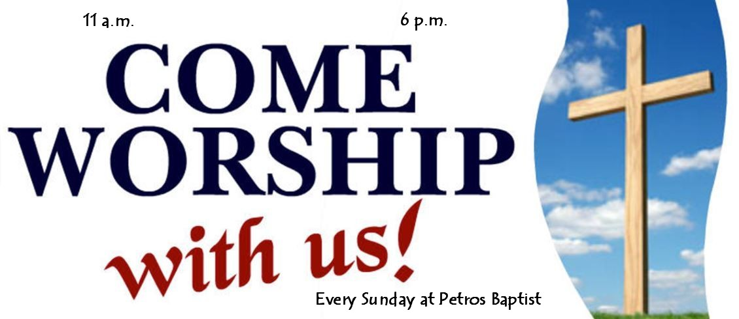

Pastor Dave Brumbaugh - Worship begins at 9:30am... unless otherwise noted!

Join us in person or via Facebook Live or Zoom!

No computer or smart phone? No problem! You only need a phone to listen to Worship via Zoom!
Dial: 1-646-558-8656 and when prompted, enter the Meeting ID 913 8085 8414 and listen to the voice prompts for simple directions. If you are asked for a password/passcode, enter 848423

April Worship Schedule

April 7 – Second Sunday of Easter
Acts 4:32-35; John 20:19-31
Message “Walking Through the Closed Door”

April 14 – Third Sunday of Easter
Acts 3:12-19; Luke 24:36-48
Message “Witnesses”

April 21 – Fourth Sunday of Easter
Acts 4:5-12; John 10:11-18
Message “Peter’s Redemption”
April 28 – Fifth Sunday of Easter
Acts 8:26-40; John 15:1-8
Message “Bearing Fruit”
Lunch, Bingo & Games following Worship

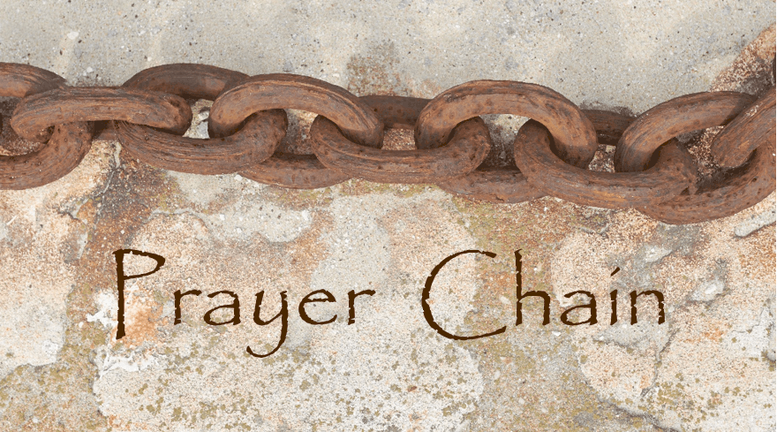

The Prayer Chain is ready to pray for you!
If you need prayers for yourself or a loved one, reach out to Pastor Dave, or the church office and we will send the request through the Prayer Chain.

The Property Committee will meet on Sunday April 7, following Worship in Fellowship Hall. Topics to be discussed include following up on the sound system project and the electronic sign. Anyone interested in these, or other church property related items is welcome to attend!

Volunteers are needed to unpack clothing in Fellowship Hall on Tuesday April 16th,
from 12:30-5:00pm. All are welcome to come and go as you are able.
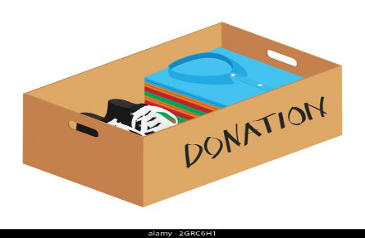

Lunch Bunch! Join us for a lunchtime gathering, at a local restaurant, for conversation, food, and fellowship! Everyone is welcome to attend, just sign up (fellowship board on the ramp) so that the selected restaurant has enough space set aside for our group. Tuesday April 9th, we will meet at Doc’s Irish Pub in Gilbertsville at 11:30am. If you have any questions, please contact Kim Yerger (1-610-730-7204)

25₵ Sale, Indoor & Outdoor Flea Market will take place on Saturday April 20th from
8am- 11am. If you are able to lend a hand with either set up or tear down, or anytime in between please reach out to Rona to help downstairs, or Kim Marburger to help upstairs with the 25₵ sale.
This event will be the first of the year that we will have space for outdoor vendors available! No pre-registration is required to be a vendor, but registration & vendor set-up will take place between 6:30-7:30am with the line of vendor vehicles forming at the basketball net. The cost of a space is a $10 donation to Calvary. Any additional questions regarding the outdoor vendors may be directed to the church office. Thank you for your time and talents to help make these events successful!

A Clothing & More Giveaway will take place in Fellowship Hall on Saturday April 27th from
9am- 11am. If you are able to lend a hand with either set up or tear down, or anytime
in between please reach out to Kim Marburger to help upstairs with the 25₵ sale.

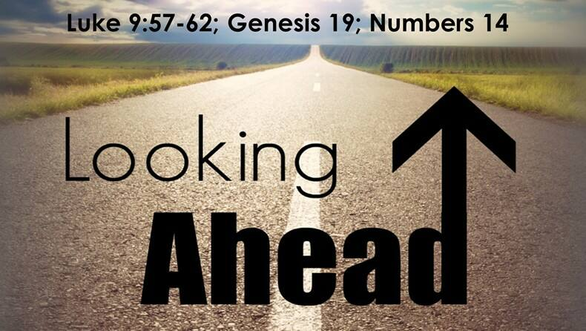

25₵ Sale & Indoor & Outdoor Flea Market will take place on Saturday May 18th from
8am- 11am. Outdoor space will be available for vendors!

* Thank You to everyone that helps promote, volunteer, participates, and
gives their time to make events successful! *

~ Upcoming Event! We will gather for Bingo and Lunch on April 28th, following Worship. Please bring a wrapped gift $5. Lunch will be provided. Bring a dessert to share if you wish. Sign up on the Fellowship Board so we can order enough lunch for everyone!

~ Are you interested in going on a bus trip to Lancaster Sight and Sound in October to see “Daniel”? We are thinking about organizing a bus trip, but we want to make sure that enough people are interested. If this is something that you would like to participate in, kindly put your name on the “I’m Interested” sign-up sheet located on the Fellowship Board on the ramp.

*For any questions regarding any of these Christian Education events, please see
Becky Crist, Tracey Frey or Connie Jordan.

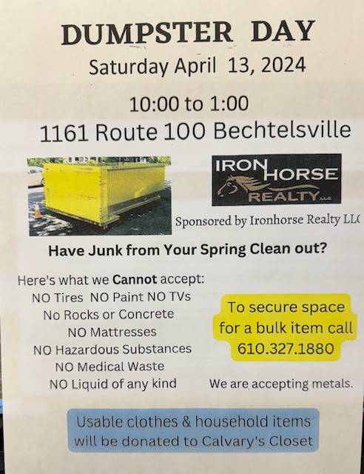

Basket Raffle Update: This year we will hold one basket raffle fundraiser. We are preparing to make this the biggest and most exciting basket raffle at Calvary yet! To help make this successful, please have all raffle baskets to Calvary by Sunday August 18.
Tickets will be sold between Saturday August 24 all the way up through our Annual Christmas Bazaar, on Saturday November 16. Winning tickets will be drawn at 1:00pm at the end of the Bazaar. (Winners do not need to be present to win!)
Any additional questions may be directed to Kim Marburger or the church office.

Please remember to swipe your Save-A-Tape card when you check out at Redner’s Markets.
The Save-A-Tape card MUST be used for your purchase to be credit to the church’s rebate total. Thanks again to everyone for turning in the tapes. Thank you to Marlene Latshaw for all the organizing and adding!
(If you aren’t familiar with the Save-A-Tape program, stop by the customer service desk next time you shop at Redner’s)

YOU are invited to gather for “Coffee and Conversation” on Sunday mornings at 8:45 AM in Calvary’s Fellowship Hall. Everyone is welcome to attend this time of fellowship! If you wish to provide a breakfast danish, treat, fruit, or snack, please see Marlene or Becky.

Niantic - Union Cemetery Guidelines
All planting of shrubs, trees or plants is prohibited. Remove all winter decorations 3 weeks before Easter. April through October all flowers and memorials will be removed 7 days after all holidays. All arrangements affixed on top of the gravestones may remain until they are unsightly.

Aluminum Can Collection/Recycling at Calvary Please continue to bring your bagged aluminum cans to the lower double doors and place them in the black can marked “can recycling”

Church News Box at Calvary
The little mailbox on a red pedestal holds copies of monthly newsletters, calendars of events, daily devotional books, and more! If you pick up your newsletter in person, you are invited to pick up your newsletters from this box if you are not able to pick it up while attending Worship.
This mailbox is open anyone! The red pedestal mailbox is located at Calvary’s lower double doors.

Online Giving at Calvary!
Online Giving at Calvary! With this giving option through Vanco, you have the ability to choose where you would like your offering designated, whether it be the General Budget, OCWM, Building Maintenance, or the Memorial Fund. There are 3 ways that you can access Vanco to use online, electronic giving...
- Use the following link on your computer:
https://secure.myvanco.com/L-ZJAT/home
- Use the camera on your smartphone or tablet to scan the below QR code, which will provide a link to the page for online giving.
3. Download the Vanco Mobile Faith Engagement App from your app store on your smartphone or tablet and create an account.

*If you have any questions regarding using the Vanco online giving option, please contact Heather.

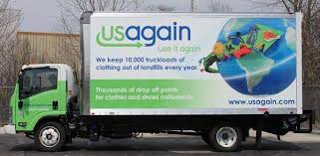
USAgain CLOTHING BINS at Calvary Thank you to all that help to fill our bins and help to reduce, reuse, and recycle clothing materials! Please keep in mind that once bags are dropped into the collection bins, the church has no access to them. So, if you are wanting to donate items to the Flea Market, or to Calvary’s Closet, please drop your items off at the lower doors. Thank you!

USAgain is a clothing and shoes collection company. 90% of the gently used clothes and shoes collected are reused. The items are taken to a warehouse where they are bundled into half ton cubes and shipped to Central America. For every full bin, one tree is planted. Calvary UCC has five bins on our property and we receive $425/month from USAgain for being a collection site.

Calvary’s Fellowship & Social Ministries Wish List
As you are probably aware by now, the Fellowship & Social Ministries Committee are doing
BIG things around Calvary! You may have noticed over the last few months different requests for items that make the flea markets possible. The items that we use the most have been compiled into a list to make it simple to find what is needed, if you would like to donate any of them.

- Kitchen size, 13-gallon garbage bags
- 3M Blue painters’ tape (1” width)
- Avery self-adhesive address labels #5160
- Ziplock bags; 1 to 3 gallon sizes & sandwich size.
- Paper grocery or shopping bags

Any of these items may be given to Heather, Linda West, Rona, or Kim Marburger at
any time. Thank you for your continued support of our efforts!

___Notes from the Administrator’s desk…_____

- *The MAY Newsletter Deadline is
Noon on Monday April 22nd*

April Birthdays

4/3 Jacob Miller
4/5 Linda Hilbert & Daniel Frantz
4/11 George LaFaver
4/13 Judy Meck
4/16 Denise Mathias
4/22 Tyson Kurtz
4/24 Marlene Latshaw
4/26 Ashley Latshaw, Karlynn Miller &
Heather Spaccarelli

*If you have a Birthday during the month and it was not mentioned, or the date is listed wrong, please let the office know. We are working to keep our records updated and your help in this effort is appreciated. Thank you!

- If you are going to the hospital, having surgery, or have recently been in the hospital, please inform Pastor Dave in one of three ways:
- Call him on his cell phone: 1-717-466-1216
- Email him: trumpet@dejazzd.com
- Call the Church office (1-610-652-5023) and leave a message

Katherine & George Jacob, Jr.
14 Standish Ln.
Hereford, PA 18056
1-610-702-4221

Barbara Moser
Frederick Living
2849 Big Rd. Apt 1102
Zieglerville, PA 19492
1-610-652-2263

Paul Schollenberger
Frederick Living
2849 Big Rd. Apt 1225
Zieglerville, PA 19492
1-610-652-5503

Linda Hilbert
Wilson Manor - Saucony Cross Complex
240 Wilson Manor
Kutztown, PA 19530-8614
1-484-641-5248

Thelma Borchelt
Frederick Living
2849 Big Rd. Apt. 1211
Zieglerville, PA 19492
1-610-652-5115

Sallie & Grant Fronheiser
241 Hill Church Rd.
Bechtelsville, PA 19505
1-610-451-2770

Janet Kulp
Amity Place Room #123
139 Old Swede Rd.
Douglassville, PA 19518
1-610-385-9745

Lillian Miller
3711 Hershey Ct.
Whitehall, PA 18052-3369
1-610-769-7318

Eileen Haring
1828 Big Rd.
Gilbertsville, PA 19525
1-610-754-6046

George LaFaver
450 N. Krocks Rd. Apt 367
Allentown, PA 18106
1-484-765-9191

