The hands & feet of calvary
United Church Of Christ
May 2023
1231 Route 100, Barto PA 19504
phone # 610-652-5023
Church Office: calvaryucc@gmail.com Website: www.calvaryuccbarto.com
Clothing & Outreach Ministry: calvarysclosetbarto@gmail.com
Join us on FaceBook! Calvary UCC Barto

Dave Brumbaugh, Pastor
Heather Spaccarelli, Administrator
Becky Crist, Consistory President
Linda Himeback, Treasurer

Pastor Dave’s Reflections

The Easter season is upon us, and from what I have heard from many of our members and friends who attended holy week services from Palm Sunday through Easter, we were blessed with high spirited and meaningful worship.

The season of Easter ends on May 21, when we will actually celebrate Ascension Sunday. You are invited to wear something white for that worship service. May 28 is Pentecost Sunday, the celebration of the Christian Church’s birthday, and a Sunday to wear something red.

The Rite of Confirmation will take place on Sunday, June 11, with a pot luck luncheon and celebration after worship for confirmand Alyssa Crist.

A consistory meeting took place on Sunday, April 23, after church. I thought it was a great meeting in that amongst the agenda items, there was some frank discussion and sharing about the future of Calvary Church. I was initially hired to be Pennsburg’s and Calvary’s shared
Ministry pastor on July 1, 2021. Since July 1, 2022 I have been serving and will continue to serve as Calvary’s designated ¾ time pastor through the end of 2024. My observations coming out of our recent consistory meeting are threefold:

- There are a majority of leaders and members who understand that, in order for us to have a chance to grow our church, we will need to do what growing churches do, make some changes, and embrace “faith first” attitudes and actions. To this end, the consistory has asked me to expand the worship committee’s membership for a special task of exploring how to improve our sound system and have it compatible for future expansion.

- There were concerns expressed about money. I understand these concerns. I appreciate them. However, in my 37 years of ministry experience, churches that began with money concerns instead of visioning and doing what is necessary to improve, do not grow. Yes, we need to be mindful of financial realities, but our current position with over $400,000 in investments and a liquid cash checking account in the black tell me that we can proceed in faith. I have pastored growing churches that did not have those advantages. Plus, from what I have heard about Calvary, we are a congregation who has met past challenges with generosity and faithful giving.

- Among all the talk about people’s vision, there is one vision that I will always come back to: What is God’s vision for Calvary Church? Where is the Holy Spirit leading us? How are we answering Christ’s call to be faithful stewards of the many gifts that we possess? There are healthy visions, there are unhealthy visions, and there are churches with no
true vision that keep spinning their wheels in the sand.

This I know for sure. The past is gone. Churches who seek to recapture the past or prevent the spirit of true growth will only die a slow or quick death. We are not here to hang on. We are here to serve Christ. That takes on new and different forms in today’s church. These are not only my opinions based upon experience, but every church growth author’s, leader’s, and pastor’s recommendations. To heed these realities, which our church growth team has been studying and urging, is to begin the journey towards becoming a healthier church. To go beyond the talking and discussion stage to action is to say to God: “We are listening and responding to your Spirit.”

Blessings,
Pastor Dave

___________________________________

5/28 Consistory Meeting, Following Worship

2023 Calvary Consistory Officers

President – Becky Crist
Vice President – Rona Britton
Secretary – Sherry Bauer
Treasurer – Linda Himeback

Elders: Harold Albitz, Sherry Bauer, Kim Marburger, Marlene Latshaw
Deacons: Rona Britton, Tracey Frey, Becky Crist, Sonya Spotts, Linda West

Calvary’s Corner, a note from your Consistory…
Hooray for May! I am sure we are all looking forward to warmer days and outdoor fun. The countdown is on for summer! Thank you to all who sorted, priced, donated items and precious time for our Spring Flea Market, 25₵ Sale, and Basket Raffle. Even though we are not holding our meal fundraisers, the flea markets, pop ups, and clothing sales are going strong and keeping our fundraiser budget in good standing. Thank You!!!
Calvary continues to be a strong presence in our community through our outreach ministries. We recently helped several families affected by the devasting fires in our area, and continue to provide for those in need through The Ann Frances Outreach Foundation. The Boyertown School district has also contacted us, and we are now included on their resource page for those in need within the school district. If you are in need or know someone in need, please contact Calvary. We are blessed to be able to provide clothing and household items where needed.
Thank you for your support. Calvary continues to remain strong due to your generosity through giving, (in person, online and mail), your donations for the flea market, items for our outreach program, and the time members give to keep events at Calvary going. Our Calvary family and friends are Awesome! Thank you so very much! The people of Calvary ARE Calvary! This is possible because of you!
Please note that Calvary is no longer a polling location. Morning Star has taken over the responsibility, starting with the upcoming election which will be held on May 16th.
Did you know that we will celebrate the 30th anniversary of our Building Addition this fall? Plans are being made to recognize and celebrate this great accomplishment.
Confirmation Class has begun and Pastor Dave and Tracey Frey are meeting with Alyssa in preparation for joining the church. Alyssa has a painting on display in the narthex. We have been working through the books of the bible, creation, the church year, stained glass windows, the meaning of colors throughout our year as well as names of things and parts of the Sanctuary (which

is actually the Nave, ask Alyssa where the sanctuary is!). Thank you for your support of this amazing youth!
We had a very good discussion during our meeting about looking into our outdated sound system, as we have a memorial fund donation toward improving it, and what we see the Calvary of tomorrow looking like. What is your vision for Calvary? We would love to hear your thoughts, be it the service, the building, the music, the grounds…What do you see us looking like for the next generations to come? We started by updating the nursery in the back of the church. Pop in and check out this peaceful fun area. While it is the nursery, it is also the perfect place for an adult who needs a comfy place to rest if needed. Please feel free to join our Consistory meeting or put your thoughts down on
paper and put them in the offering plate in an envelope marked VISION. We would love to hear your thoughts and ideas. I have my vision, what is yours?
Please take note of the announcement for our big Back to School giveaway. Plans are being made and donations are being collected. Let’s make this another great day that makes the news!

Words from 1 Timothy 4:10
“That is why we labor and strive, because we have put our hope in the living
God, who is the Savior of all people, and especially of those who believe”

May you feel the Lord’s blessings every day,
Your Consistory,
Becky Crist, Rona Britton, Sherry Bauer, Kim Marburger, Marlene Latshaw,
Sonya Spotts, Linda West, Harold Albitz and Tracey Frey

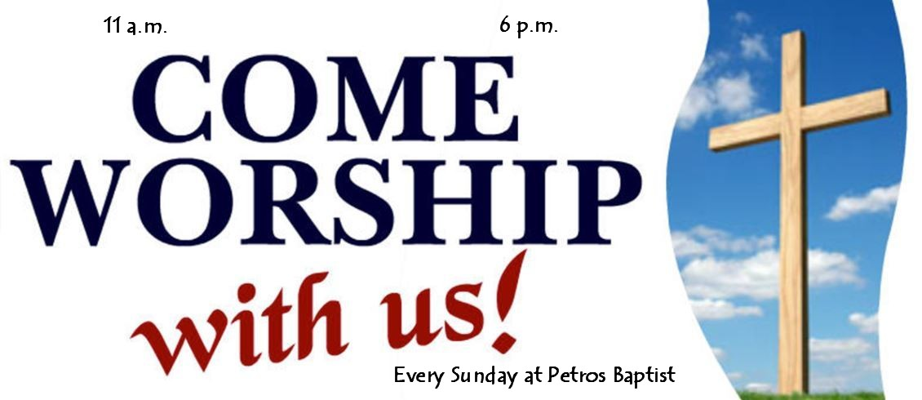

Pastor Dave Brumbaugh - Worship begins at 9:30am... unless otherwise noted!
Join us in person or via Facebook Live or Zoom!

No computer or smart phone? No problem! You only need a phone to listen to Worship via Zoom!
Dial: 1-646-558-8656 and when prompted, enter the Meeting ID 913 8085 8414 and listen to the voice prompts for simple directions. If you are asked for a password/passcode, enter 848423.

Worship Schedule
May 2023

May 7 – Fifth Sunday of Easter
Supply Pastor: Rev. Meagan McLeod

May 14 – Sixth Sunday of Easter
Supply: Threefold Blessing

May 21 – Ascension Sunday
Epistle Lesson: Acts 1:6-11
Gospel Lesson: Luke 24:44-53
Message “Going Away, Coming Back”

May 28 – Pentecost Sunday
Memorial Day Weekend
Epistle Lesson: Acts 2:1-21
Gospel Lesson: John 7:37-39
Message “Christ Centered, Holy Spirit Led”

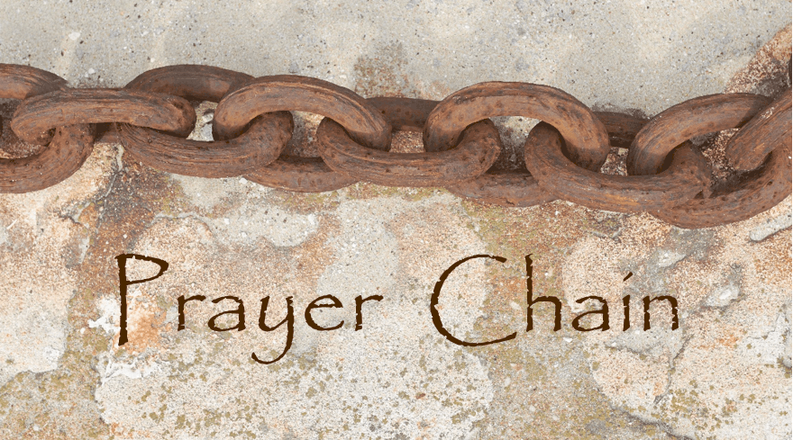
The Prayer Chain is ready to pray for you!
If you need prayers for yourself or a loved one, reach out to Pastor Dave, or the church office and we will send the request through the Prayer Chain.

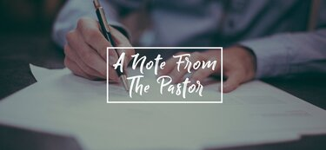

Pastor Dave’s Schedule

~ Pastor Dave posts his weekly office hours in the bulletin for the coming week. Due to visits, activities, and meetings outside of the church, office hours will vary from week to week. Call Pastor Dave for availability of times to meet with him either during or apart from office hours
(1-717-466-1216)

~ Pastor Dave will be on vacation from May 1st – May 18th. If you have a pastoral need or emergency during this time, please reach out to Becky Crist (1-267-261-8509) OR the church office,
(1-610-652-5023) so that we can get you in touch with the Pastor on call.

Free Community Giveaway (clothing, shoes, books, housewares, and more) Saturday, May 6, 8:00 - 11:00 AM. All are welcome! Volunteers are needed during the event to greet visitors, and from 11:00 - 12:00 to clean up.

Lunch Bunch! Join us for a lunchtime gathering, at a local restaurant, for conversation, food, and fellowship! Everyone is welcome to attend, just sign up (fellowship board on the ramp) so that the selected restaurant has enough space set aside for our group. Tuesday May 9th, we will meet at Giovanni’s Route 562 café & pizzeria in Boyertown at 11:30am. If you have any questions, please see Kim Yerger.

Volunteers are needed to unpack clothing on Tuesday, May 30 and Wednesday, May 31 from 4:00 - 7:00 PM in preparation for the 25-cent sale and flea market on Saturday, June 3.

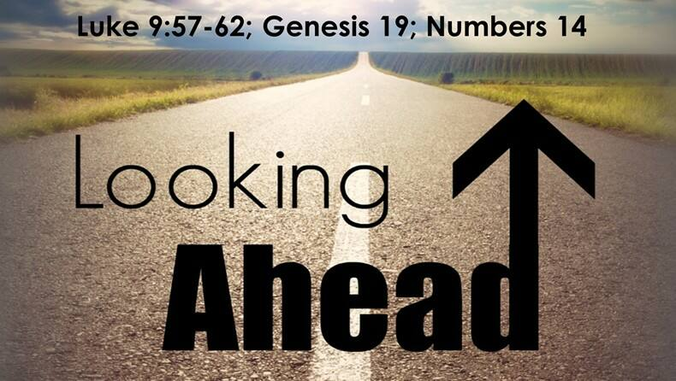

Fellowship & Social Ministries will meet on Wednesday June 28 at 7pm in Fellowship Hall to discuss the final details of the Back-to-School Free Community Event which is scheduled for Saturday August 19th. If you are able to volunteer your time to help make this event successful, please try to attend this meeting. Any questions may be directed to Becky Crist.

Free Community Back-To-School Event will be held on Saturday August 19th from 9am-1pm. This is a free event for everyone in the community with activities, clothing, lunch, music, school supplies, special guests, and more! We had such a wonderful response from the event last year that we decided to do it again! If you have an idea, would like to make a donation, or would like to help, please see Becky Crist. An event flyer will be available soon!

* Thank You to everyone that helps promote, volunteer, participates, and
gives their time to make events successful! *

YOU are invited to gather for “Coffee and Conversation” on Sunday mornings at 8:45 AM in
Calvary’s Fellowship Hall. Everyone is welcome to attend this time of fellowship! If you wish to
provide a breakfast Danish, treat, fruit, or snack kindly sign up on the Fellowship Board (located on the ramp) for a specific date of your choice. Please see Becky or Marlene if you have any questions.

Attention all 2023 Graduates (or families of Graduates) Please email the church office by May 20th with the student Name and School for the graduate. For all graduates who are members, or parents are members, Calvary has some funds available to support you as you graduate and continue your journey whether it be in the form of college, a trade school, or employment. If you would like to seek this financial gift, please see Becky Crist by May 31st. These funds are offered to assist you with incidental life expenses such as books, transportation, insurance, etc. We care about you. We love you. We hope this gift will help you on your journey through life. ALL graduates will be recognized on Graduate Sunday, June 4th.

Aluminum Can Collection/Recycling at Calvary Please continue to bring your bagged aluminum cans to the lower double doors and place them in the cans with the blue lids. Thank You for your continued support.

Wanted! Folks to be part of Greeter teams. Prior to Covid we had Usher teams, which were teams of 4. Their duties were to collect & present offering, help with Communion and greet folks at the doors when they entered.

We are looking for volunteer groups of 2, to be Sunday Morning Greeters. Opening the doors when people arrive, greeting folks while inviting them to Fellowship Hall for Coffee and Conversation. Just in general folks who are willing to be a friendly face on a Sunday morning and help all who enter our church.

Not able to help on a Sunday morning? We are also looking to have folks who are willing do to this during our Events at Calvary.

You do not need to commit to every Sunday or every event, we will work with your schedule! If interested please reach out to Becky Crist or any Consistory Member.

Thank you!

Please remember to swipe your Save-A-Tape card when you check out at Redner’s Markets. The Save-A-Tape card MUST be used for your purchase to be credit to the church’s rebate total. Thanks again to everyone for turning in the tapes. Thank you to Marlene Latshaw for all the organizing and adding!

We have a need for Ziplock Bags once again! Gallon size and 2 or 2½ -gallon sizes are the current sizes needed for the Flea Market. If you have any of the clear zipper bags that blankets and comforters are sold in, those can also be used! They are used to package up linens, if you wish to donate some, or have any questions, please see Linda West.

Canning Jars are collected year-round, and saved for chow-chow and our annual Vegetable Soup Sale. You may leave your empty (pint and quart) jars, lids, and bands, at the lower double doors at any time. Thank you for recycling these items to help keep the cost of materials down!

Wider Church News
The Annual Spring Meeting of the PSEC will take place on Friday-Saturday June 2-3. Pastor Dave will be leading a luncheon round table discussion for pastors and delegates on “the search process.” *If you are interested in attending the event as a delegate, please see Pastor Dave.

Church News Box at Calvary
This little mailbox on a red pedestal holds copies of monthly newsletters, calendars of events, daily devotional books, and more! If you pick up your newsletter in person, you are invited to pick up your newsletters from this box if you are not able to pick it up while attending Worship. This mailbox is open anyone!
The red pedestal mailbox is located at Calvary’s lower double doors.

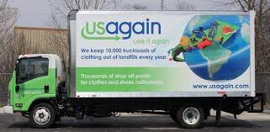
USAgain CLOTHING BINS at Calvary Thank you to all that help to fill our bins and help to reduce, reuse, and recycle clothing materials! Please keep in mind that once bags are dropped into the collection bins, the church has no access to them. So, if you are wanting to donate items to the Flea Market, or to Calvary’s Closet, please drop your items off at the lower doors. Thank you!

An invitation from the family of Donald Nuss…

If you are able to attend the luncheon, kindly RSVP to the family at: dfoster199@comcast.net
or by calling their daughter, Debbie at 610-269-5971, by Wednesday May 10th.

As we look ahead to our Back-to School Free Community event, collection boxes have been placed in the Narthex and outside of church office for School Supplies. Donated school supplies will be distributed at our event in August. We feel that it is important to begin collecting supplies now, as we have begun the planning for this exciting event and want to help as many children within our community be ready & prepared to return to school in the fall. Please keep in mind that items that we are collecting should be new, or unused. Needed items include: Pencils, Pens, Erasers, Notebooks, Folders, Binders, Glue Sticks, Colored Pencils, Safety Scissors, Markers, Crayons, Pencil Sharpeners, Backpacks, Calculators, Rulers, Tape, Highlighters, and more! Collection bins will be available until Sunday August 13th for contributions. Thank you!

___Notes from the Administrator’s desk…_____

*The JUNE Newsletter Deadline is
Noon on Wednesday May 24th*

*The JULY & AUGUST Combined Newsletter Deadline is
Noon on Monday July 10th*

May Birthdays

5/4 Johanna Miller
5/6 Rebecca Marburger
5/9 Courtney Moatz
5/12 Trevor Crist
5/13 MaryAnn Galloway
5/16 Andrew Bellesfield, Fred Kroncke, Sharon Tarantino
5/22 Donna Kroncke
5/28 Jenna Marburger
5/29 Christopher Mathias, Virginia Mutter

*If you have a Birthday during the month and it was not mentioned, or the date is listed wrong, please let the office know. We are working to keep our records updated and your help in this effort is appreciated. Thank you.

May Anniversaries
5/16 Brenda Fidler & Pastor Dave Brumbaugh (25 years)
5/21 Joan & Warren Albitz (62 years)
5/22 JoAnn & Harold Albitz (52 years)

*If you have an Anniversary during the month and it was not mentioned, or the date is listed wrong, please let the office know. We are working to update our records and your help in this effort is appreciated. Thank you.

- If you are going to the hospital, having surgery, or have recently been in the hospital, please inform Pastor Dave in one of three ways:
- Call him on his cell phone: 1-717-466-1216 - Email him: trumpet@dejazzd.com
- Call the Church office and leave a message

Mabel Schultz
Frederick Living
2849 Big Rd.
Third floor, room 1311
Zieglerville, PA 19492

Barbara Moser
Frederick Living
2849 Big Rd.
First floor, Apt 1102
Zieglerville, PA 19492
610-652-2263

Paul Schollenberger
P.O. Box 141
New Berlinville, PA 19545 610-367-9655

Pauline Weller
146 Anthony’s Mill Rd.
Barto, PA 19504
610-845-8059

Linda Hilbert
Wilson Manor - Saucony Cross Complex
240 Wilson Manor
Kutztown, PA 19530-8614
484-641-5248

Thelma Borchelt
Frederick Living
2849 Big Rd. Apt. 1211
Zieglerville, PA 19492
610-652-5115

Sallie Fronheiser
241 Hill Church Rd.
Bechtelsville, PA 19505
484-944-4504

Janet Kulp
Amity Place Room #123
139 Old Swede Rd.
Douglassville, PA 19518
610-385-9745

Judy Whitman
109 Fairfield Dr.
Barto, PA 19504
610-754-8630

Lillian Miller
3711 Hershey Ct.
Whitehall, PA 18052-3369
610-769-7318

Eileen Haring
1828 Big Rd.
Gilbertsville, PA 19525
610-754-6046

A fond memory to share…

My Uncle Penny loved baking. Recently Anita Schwenk visited the Philadelphia Art Museum. She found a cookbook in the gift shop. While she didn’t need another cookbook, something kept drawing her back to it, and she bought it. On Easter Sunday, she shared the surprise of seeing an article and recipe from Penny in the book. He has been gone many years now, but some of you may still remember his pies and cookies. Now you too can have a copy of his pie crust recipe! Thanks Anita!
-Tracey Frey

